**Project Title:**

**Employee Management System Using AVL Trees**

**1. Introduction**

The "Employee Management System Using AVL Trees" project aims to develop a robust software solution for managing employee records efficiently. This project utilizes AVL Trees, a self-balancing binary search tree data structure, to optimize storage and retrieval operations. The system allows users to add new employees, search for employees by ID, and display all employees' records.

**2. Project Overview**

The project involves the implementation of an Employee Management System using Java programming language. The core data structure used for storing employee records is AVL Trees. AVL Trees ensure that the height difference between the left and right subtrees of any node (balance factor) is at most one, thereby maintaining optimal balance and improving search efficiency.

**3. Project Components**

* AVL Tree Implementation: The project includes a custom implementation of AVL Trees, comprising Node and AVLTree classes. These classes provide methods for insertion, deletion, searching, and balancing operations on AVL Trees.
* Employee Class: Represents an employee record with attributes such as ID, name, and designation.
* Employee Management System Class: Contains methods for adding new employees, searching for employees by ID, and displaying all employee records. It integrates AVL Tree operations for managing employee data efficiently.

**4. Project Execution**

The project follows a modular approach, with each component responsible for specific functionality:

1. AVL Tree Implementation: The AVL Tree classes (AVLNode and AVLTree) are developed to handle AVL Tree operations. These classes ensure the correct insertion and balancing of nodes in the AVL Tree.
2. Employee Class: Defines the structure of an employee record, including attributes such as ID, name, and designation.
3. Employee Management System Class: Implements methods for adding new employees, searching for employees by ID, and displaying all employee records. It utilizes AVL Tree operations to manage employee data effectively.

**Code used in the project:**

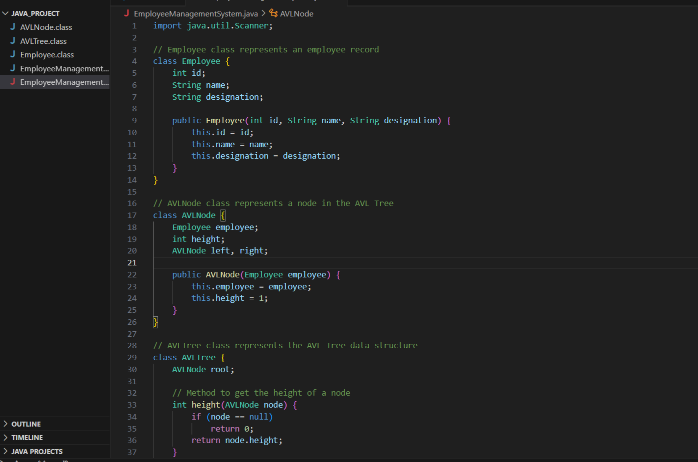

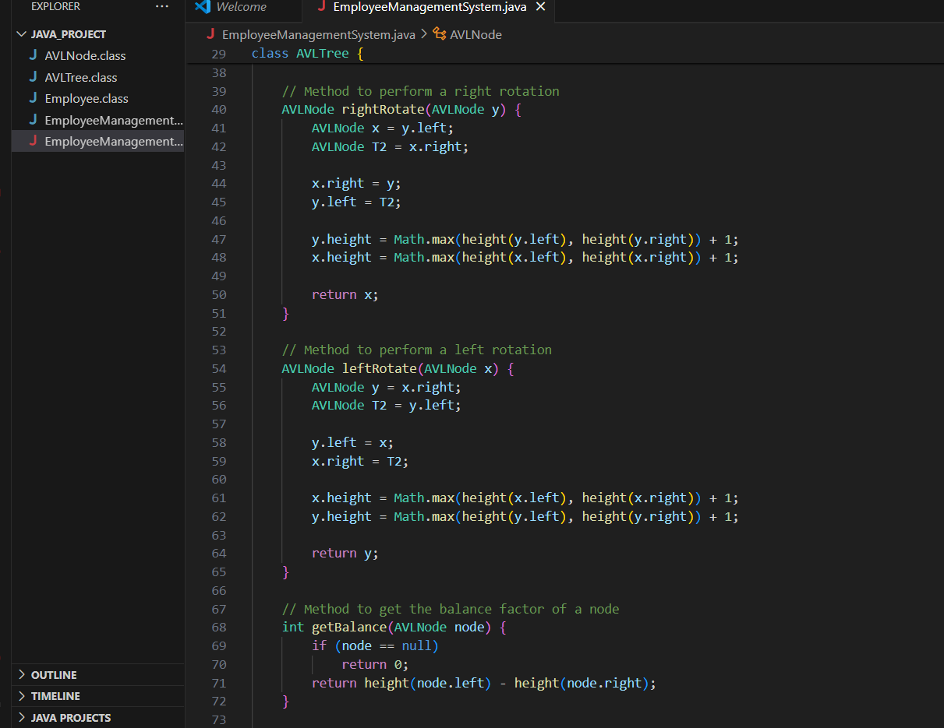

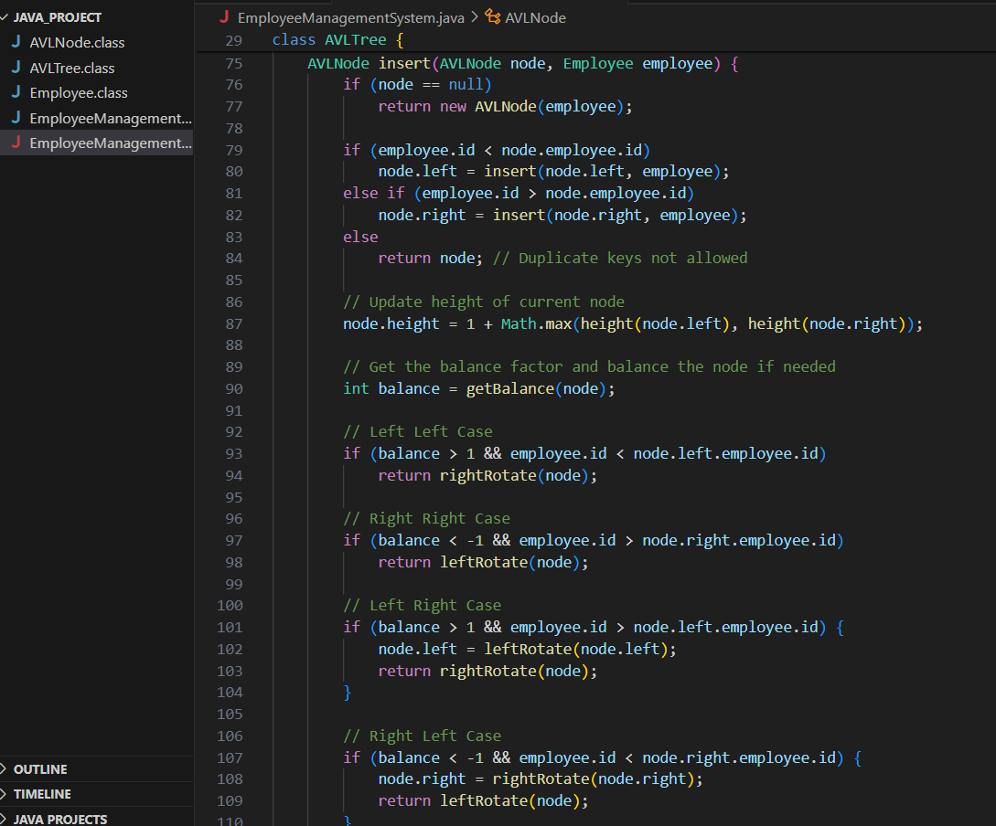

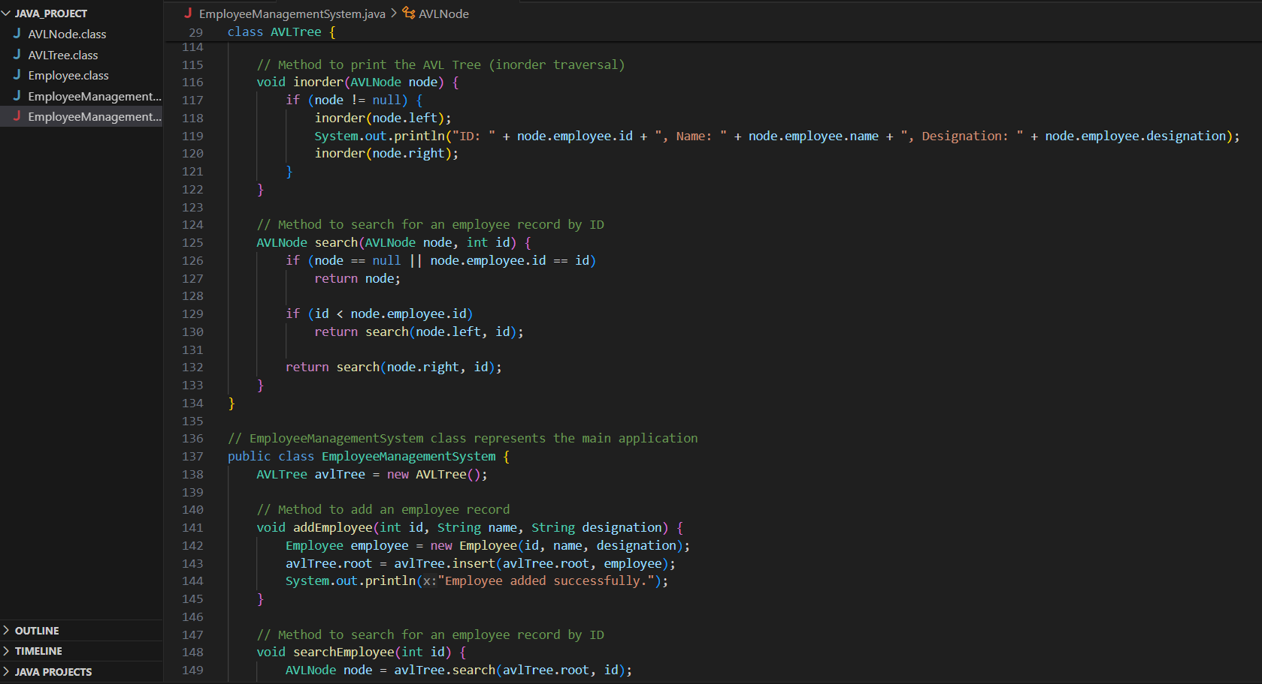

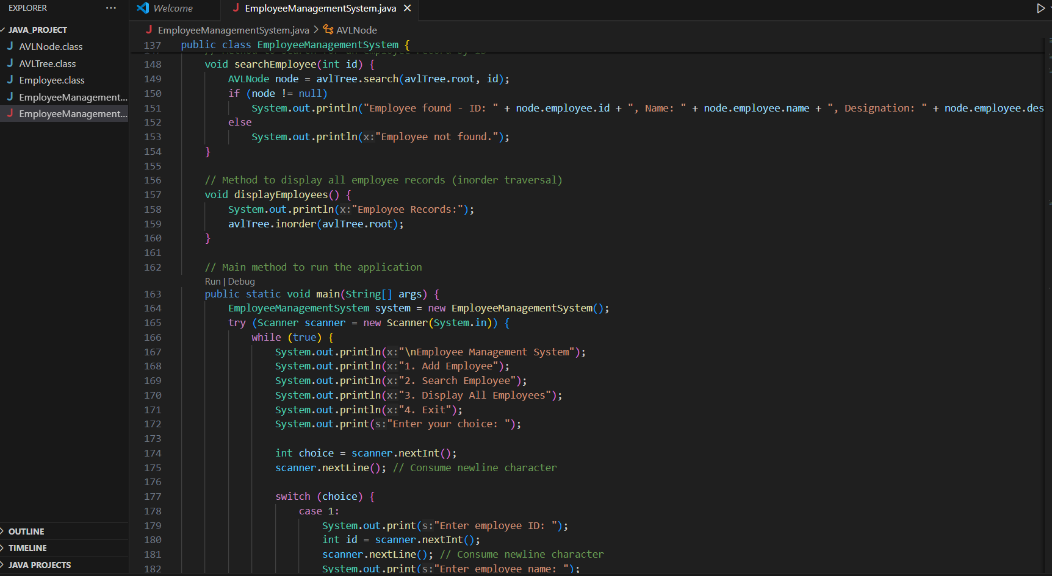

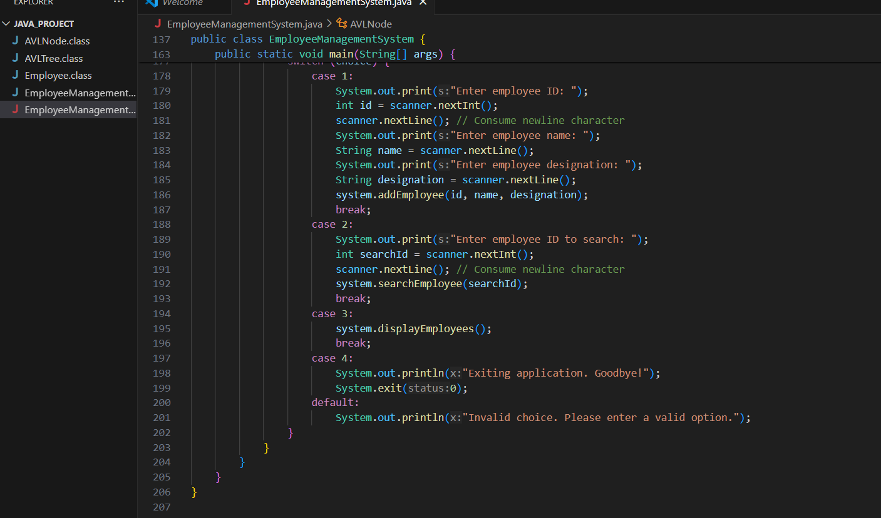

**Output:**

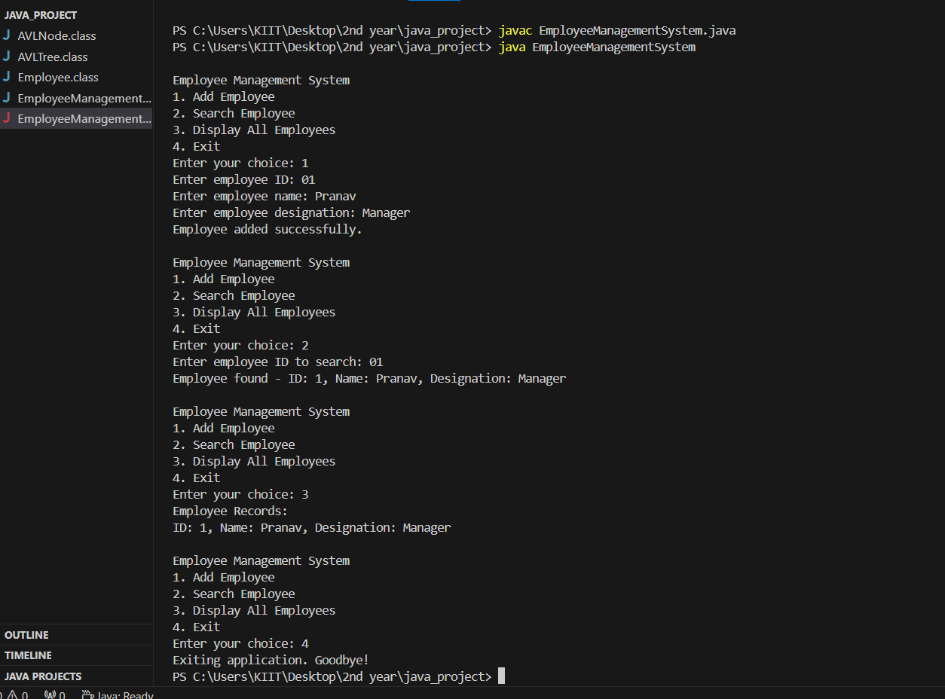

**5. Project Outcome**

The "Employee Management System Using AVL Trees" project successfully achieves its objectives:

* Provides a reliable software solution for managing employee records.
* Demonstrates the efficient storage and retrieval of employee data using AVL Trees.
* Offers a user-friendly interface for interacting with the system via the command-line interface.
* Ensures data integrity and optimal performance through AVL Tree operations.

**6. Future Enhancements**

Possible enhancements for the project include:

* Integration with a database for persistent storage of employee records.
* Implementation of additional features such as updating and deleting employee records.
* Development of a graphical user interface (GUI) for improved user interaction.
* Optimization of AVL Tree operations for further performance improvements.

**7. Conclusion**

The "Employee Management System Using AVL Trees" project showcases the practical application of data structures in software development. By leveraging AVL Trees, the project demonstrates efficient storage and retrieval of employee records, paving the way for scalable and reliable employee management solutions.

Overall, the project serves as a testament to the importance of understanding and implementing data structures effectively in real-world applications.